J.P.BADRI(192524301)
Set 4: Product Inventory Management
Dataset: Product Inventory
Product ID Product Name Quantity Available
- Create a bar chart to visualize the quantity of each product in the inventory. Label the axes and title the chart.
- Generate a stacked bar chart to show the quantity of each product within different product categories.
- Build a scatter plot to explore the relationship between product price and quantity available. Explain the findings.
- Develop a Tableau dashboard with the bar chart and stacked bar chart to allow users to interact with the data.
SOLUTION :

CODE :

import pandas as pd import matplotlib.pyplot as plt import seaborn as sns import plotly.express as px import plotly.graph_objects as gg from plotly.subplots import make_subplots df_inventory = pd.DataFrame({
'Product_ID': [1, 2, 3, 4, 5],
'Product_Name': ['Product A', 'Product B', 'Product C', 'Product D', 'Product E'],
'Category': ['Electronics', 'Electronics', 'Apparel', 'Apparel', 'Home Goods'],
'Quantity_Available': [250, 175, 300, 200, 220],
'Price': [120, 250, 45, 60, 150]
})

plt.figure(figsize=(8, 4))
plt.bar(df_inventory['Product_Name'], df_inventory['Quantity_Available'], color='mediumseagreen', edgecolor='black') plt.title('Product Inventory Quantities', fontsize=14) plt.xlabel('Product Name', fontsize=12) plt.ylabel('Quantity Available', fontsize=12) for i, val in enumerate(df_inventory['Quantity_Available']): plt.text(i, val + 5, str(val), ha='center', fontweight='bold') plt.tight_layout() plt.show()

cat_pivot = df_inventory.pivot(index='Category', columns='Product_Name', values='Quantity_Available').fillna(0) cat_pivot.plot(kind='bar', stacked=True, figsize=(8, 4), colormap='Set2') plt.title('Product Quantity Distribution across Categories', fontsize=14) plt.xlabel('Category', fontsize=12) plt.ylabel('Quantity Available', fontsize=12) plt.xticks(rotation=0) plt.legend(title='Product') plt.tight_layout() plt.show()

plt.figure(figsize=(8, 4))
sns.scatterplot(data=df_inventory, x='Price', y='Quantity_Available', hue='Product_Name', s=120) plt.title('Product Price vs. Quantity Available', fontsize=14) plt.xlabel('Price ($)', fontsize=12) plt.ylabel('Quantity Available', fontsize=12) plt.grid(True, linestyle='--', alpha=0.6) plt.tight_layout() plt.show()

print("--- Insights from Scatter Plot ---")
print("Higher-priced products (e.g., Product B at $250) tend to have lower inventory stock levels (175 units),")
print("whereas lower-priced products (e.g., Product C at $45) maintain higher stock levels (300 units) to meet expected volume demand.\n")

fig = make_subplots( rows=1, cols=2, subplot_titles=("Inventory Level per Product", "Price vs. Quantity")
)

fig.add_trace(gg.Bar(x=df_inventory['Product_Name'], y=df_inventory['Quantity_Available'], marker_color='forestgreen'), row=1, col=1)
fig.add_trace(gg.Scatter(x=df_inventory['Price'], y=df_inventory['Quantity_Available'], mode='markers+text', text=df_inventory['Product_Name'], textposition='top center', marker=dict(size=12)), row=1, col=2)

fig.update_layout(title_text="Set 4: Inventory Management Dashboard", showlegend=False, height=450) fig.show()

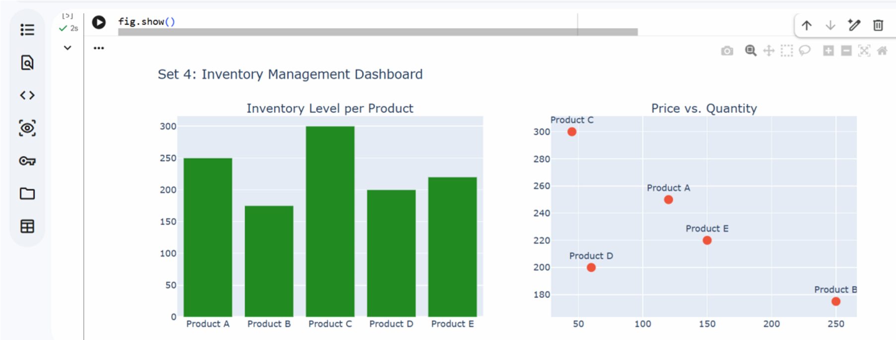
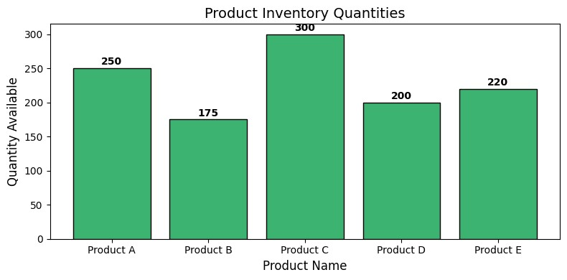
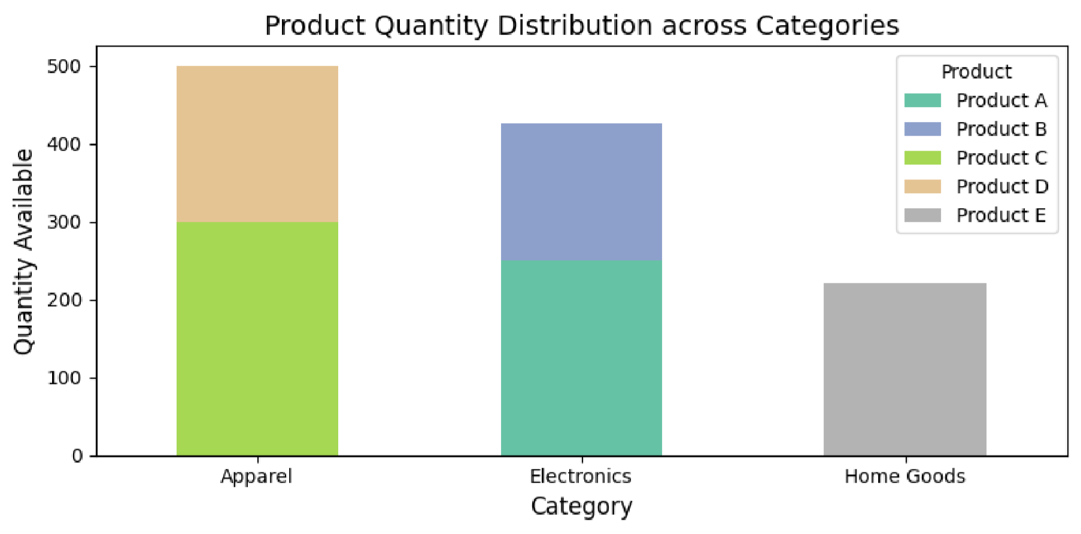
OUTPUT :

